**ntroduction to CSS Box Model | Part 2 | Cheat Sheet**

CSS Box Properties

1. Border Width

The CSS

border-width

property specifies the width of the border for all four sides of an HTML element.



1

2

3

.button {

*border-width*: 2px;

}

CSS

The CSS Property and value pair

border-width: 0px;

removes the border of an HTML element.

**Warning**

Specifying the CSS

border-style

 property for an HTML element is mandatory. Otherwise, the CSS properties like

border-color

,

border-width

 will not appear in the browser. The HTML

button

 element is an exception as it appears with a border in the browser by default.

2. Border Radius

The CSS

border-radius

property specifies the roundness of the corners of an HTML element.



1

2

3

.button {

*border-radius*: 20px;

}

CSS

You can use the below CSS properties to round a specific corner of an HTML element.

| Property |
| --- |
| border-top-left-radius |
| border-top-right-radius |
| border-bottom-left-radius |
| border-bottom-right-radius |

**Quick Tip**

Specifying the background color for an HTML element makes the border radius more visible.

3. Border Color

The CSS

border-color

property specifies the color of the border for all four sides of an HTML element.



1

2

3

.button {

*border-color*: orange;

}

CSS

**Warning**

Specifying the CSS

border-style

 property for an HTML element is mandatory. Otherwise, the CSS properties like

border-color

,

border-width

 will not appear in the browser. The HTML

button

 element is an exception as it appears with a border in the browser by default.

4. Border Style

The CSS

border-style

property specifies the style of the border for all four sides of an HTML element.



1

2

3

.button {

*border-style*: dashed;

}

CSS

You can use one of the below values of the CSS

border-style

property.

| Value |
| --- |
| dotted |
| dashed |
| solid |
| none (default) |

5. Padding

The CSS

padding

property specifies the space around the content of an HTML element.



1

2

3

.card {

*padding*: 10px;

}

CSS

CSS Colors

1. Hex Code

CSS Colors can be represented in multiple ways:

* Color names
* Hex Code
* HSL
* RGB and many more...

Since few colors have the Color names, Hex Codes make a good alternative to pick a wide variety of colors.

Some of the Color names and their Hex Codes are:

| Color Name | Hex Code |
| --- | --- |
| orange | #ffa500 |
| red | #ff0000 |
| blue | #0000ff |
| green | #008000 |
| - | #012d36 |
| - | #432711 |
| - | #25b1cc |



1

2

3

.button {

*background-color*: #25b1cc;

}

CSS

**How to pick a color using Hex Code**

The color picker lets you pick a color among the approximately 16,777,216 colors available.

One of the simplest ways to access a color picker is:

Type *color picker* in the Google Search bar and search it.

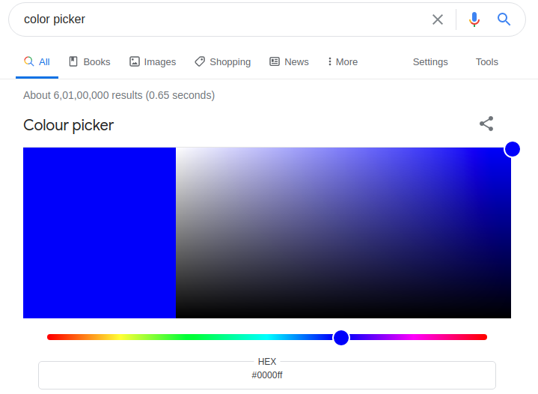

**HTML**

CSS

JAVASCRIPT

Inspect



1

2

3

4

5

6

7

8

9

10

11

<!DOCTYPE html>

<html>

<head></head>

<body>

<div class="card">

<h1>Tourism</h1>

<p>Plan your trip wherever you want to go</p>

<button class="button">Get Started</button>

</div>

</body>

</html>

**Note**

In the preview of the above code playground, you can't see the blue border around the HTML

button

 element when you click inspect because the HTML

button

 element already has borders.